2016年上海高考英语试题解析
考生注意：
1.考试时间120分钟, 试卷满分150分.
2.本考试设试卷和答题纸两部分.试卷分为第I卷（第1－12页）和第II卷（第13页），全卷共13页.所3.有答题必须涂（选择题）或写（非选择题）在答题纸上，做在试卷上一律不得分.
4.答题前,务必在答题纸上填写准考证号和姓名,并将核对后的条形码贴在指定位置上,在答题纸反而清楚地填写姓名.
第I卷(共103分)
I.Listening Comprehension
Section A
Directions: In Section A, you will hear ten short conversations between two speakers.At the end of each conversation, a question will be asked about what was said.The conversations and the questions will be spoken only once.After you hear a conversation and the question about it, read the four possible answers on your paper, and decide which one is the best answer to the question you have heard.
1.A.It is satisfactory.
B.It is luxurious.
C.It is old-fashioned.
D.It is disappointing.
2.A.On August 5th.B.On August 6th.C.On August 7th.D.On August 8th.
3.A.A waiter.
B.A butcher.
C.A porter.
D.A farmer.
4.A.In a theatre. B.In a library.
C.In a booking office.
D.In a furniture store.
5.A.She expected to a better show.
B.She could hardly find her seat.
C.She wasn’t interested in the show.
D.She didn’t get a favourable seat.
6.A.The woman often eats out for breakfast.
B.The cafeteria serves good breakfast.
C.The woman doesn’t have breakfast.
D.The cafeteria doesn’t serve breakfast.
7.A.Selling cucumbers. B.Planting vegetables.C.Cooking a meal. D.Picking tomatoes.
8.A.The man should work hard. B.The man should turn down the job offer.
C.The man may have another chance. D.The man can apply for the job again.
9.A.It is a hot and smoggy day. B.There is a traffic jam on King Street.
C.A vehicle is polluting the air.D.The man is reading a report online.
10.A.Its ending is not good enough. B.Its special effects are not satisfying.
C.It deserves an award. D.It is good except for the scary part.
Section B
Directions: In Section B, you will hear two short passages, and you will be asked three questions on each of the passages.The passages will be read twice, but the questions will be spoken only once.When you hear a question, read the four possible answers on your paper and decide which one would be the best answer to the question you have heard.
Questions 11 through 13 are based on the following passage.
11.A.$1B.$2C$3D.$ 52
12.A.Pay the bills first.
B.Spend 2% of the salary on living expenses.
C.Deposit $1000 every month.
D.Put part of the money in a savings account.
13.A.Methods of saving money.
B.Saving money for family emergencies.
C.The importance of saving money.
D.Secrets of spending money wisely.
Questions 14 through 16 are based on the following passage.
14.A.Free education.
B.A sum of money.
C.Donations from a local newspaper.
D.Gifts from many people.
15.A.Let students in before school.
B.Offer ice cream and coffee.
C.Introduce a bank into the campus.
D.Reduce the traffic jams around.
16.A.It lacks positive news.
B.It should grow into a big city.
C.It is a place worth living in.
D.It remains peaceful and quiet.
Section C
Directions: In section C, you will hear two longer conversations.The conversations will be read twice.After you hear each conversation, you are required to fill in the numbered blanks with the information you have heard.Write your answers on your answer sheet.
Blanks 17 through 20 are based on the following conversation.
Complete the form.Write ONE WORD for each answer.
Class Diary (June 13-19)
SUN
MON | 17 for after-class activity application
TUE
WED | Handing in three student 18
THU | Basketball Club meeting  Time:12:45—1:30pm Place: The 19
FRI | Filling in a form with up-to-date personal data  Time: 20 break Place: The computer room
SAT
Blank 21 through 24 are based on the following conversation.
Complete the form.Write NO MORE THAN THREE WORDS for each answer.
Who is Sue Walter? | She is 21 in court and a writer.
What is Sue’s suggestion for people with difficulties? | 22
In Sue’s eyes, what is the best part about her job? | 23 in decision-making.
What does Sue think happiness is? | 24
II.Grammar and Vocabulary
Section A
Directions: After reading the passages below, fill in the blanks to make the passages coherent and grammatically correct.For the blanks with a given word, fill in each blank with the proper form.of the given word; for the other blanks, use one word that best fits each blank.
(A)
Bags of Love
Last year, I was assigned to work at an office near my mother’s house, so I stayed with her for a month.During that time, I helped out with the housework and contributed to the groceries.After less than a week, I started noticing that the groceries were running out pretty quickly — we were always suddenly out of something.(25)_ _(wonder) how my mum could consume them so quickly, I began observing her daily routine for two weeks.To my surprise, I found that she would pack a paper bag full of canned goods and head out every morning at about nine.Eventually, I decided to follow her and (26)__ happened truly amazed me.She was taking the food to the refugee camp, in (27)_ she distributed it to children.
I asked around and found out that my mum was very well known in the area.The kids were very friendly with her and even looked up to her as if she were their own mother.Then it hit me —why would she not want to tell me about what she (28)_ _(do)? Was she worried about how I would react or that I would stop (29) __(buy) the groceries if I found out?
When she got home, I told her about my discovery.(30)__ _ she could react, I gave her a big hug and told her she didn’t need to keep it a secret (31)__ _ me.She told me that some of the children lived with an older lady in a shelter while others slept on the streets.For years, my mum has been helping out by giving them whatever food she could spare.I was so impressed by (32)_ __ selfless she was.
【答案】
25.Wondering26.what27.which28.had done29.buying30.Before31.from32.how
【解析】
试题分析：本文属于记叙文，我在无意中发现妈妈偷偷地帮助难民，赞美了妈妈善良无私的美丽品质.
25.Wondering考查现在分词做状语.动词wonder与本句主语I构成主动关系，所以使用现在分词wondering在句中做状语.
26.what考查主语从句.本句中连接代词what引导主语从句what happened，并在句中做主语.句意：发生的事情真得让我很惊讶.
27.which考查定语从句.本题定语从句的先行词是the refugee camp，关系代词which指代先行词在定语从句中作为介词in的宾语，in which相当于关系副词where.
28.had done考查时态.根据上下文可知本文介绍的是我被派到妈妈家附近工作，这是过去发生的事情，而妈妈帮助难民是在我来这里工作之前就发生的事情，所以应该使用过去完成时表示过去的过去发生的事情.
29.buying考查动词短语.短语stop to do sth停下了做另外一件事情；stop doing sth停止做某事；句意：妈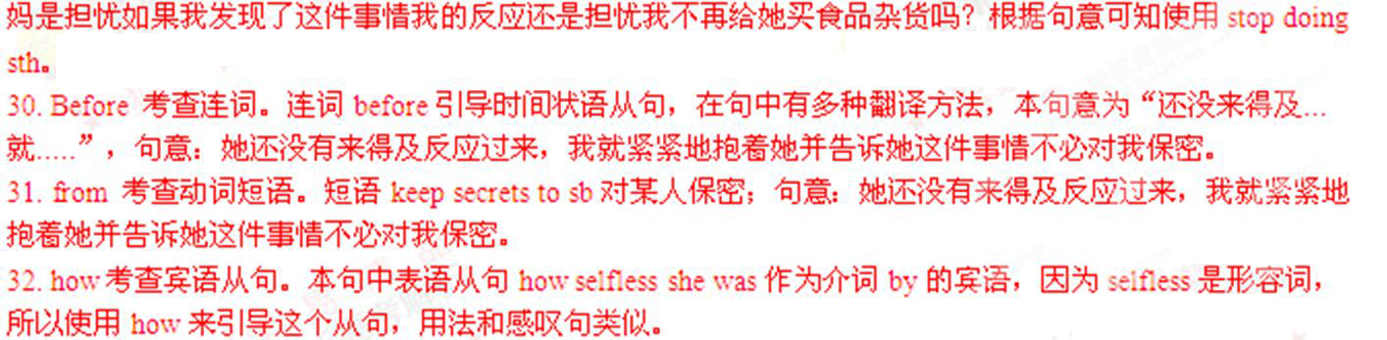
考点：考查语法填空
(B)
Stress: Good or Bad?
Stress used to be an almost unknown word, but now that we are used to talking about it, I have found that people are beginning to get stressed about being stressed.
In recent years, stress(33)____(regard) as a cause of a whole range of medical problems, from high blood pressure to mental illness.But like so many other things, it is only too much stress(34)__ does you harm.It is time you considered that if there were no stress in your life, you would achieve a little.If you are stuck at home with no stress, then your level of performance will be low.Up to a certain point, the more stress you are under, the (35)__(good) your performance will be.Beyond a certain point, though , further stress will only lead to exhaustion, illness and finally a breakdown.You can tell when you are over the top and on the downward slope, by asking yourself (36)____ number of questions.Do you, for instance, feel that too much is being expected of (37)___, and yet find it impossible to say no? Do you find yourself getting impatient or(38) ____(annoy) with people over unimportant things?...If the answer to all those questions is yes, you had better(39)__ __(control ) your stress, as you probably are under more stress than is good for you.
To some extent you can control the amount of stress in your life.Doctors have worked out a chart showing how much stress is involved in various events.Getting married is 50, pregnancy 40, moving house 20, Christmas 12,etc.If the total stress in your life is over 150, you are twice as likely (40)__ (get )ill.
【答案】
33.has been regarded34.that35.better36.a7.you38.annoyed39.control40.to get
【解析】
试题分析：本文是一篇说明文，压力成为了我们生活中常见的一个词汇.文章告诉我们一定范围之内的压力能促进我们的工作，但一旦压力过大，就会给我们的生活带来很多负面的影响.
33.has been regarded考查时态语态.本句的时间状语是in recent years最近几年以来，该时间状语通常和现在完成时连用，且句子主语stress与动词regard构成被动关系，所以使用现在完成时的被动语态形式has been regarded.
34.that考查强调句型.强调句型的基本结构为It is/was被强调成分that/who其它成分；其最大的特点就是去掉it is/was…that/who…句子仍然成立.要注意强调句型能强调除谓语动词以为的所有的句子成分.本句强调的是句子主语only too much stress.
35.better考查固定句式“The+比较级.....， the+比较级”意为“越....就越.....”.本句句意：你承受的压力越大，你的表现就会越好.所以本空使用good的比较级形式better.
36.a考查固定短语.短语a number of许多，大量；该形容词短语通常做定语修饰可数名词复数形式，本句中使用a number of修饰可数名词复数形式questions.
37.you考查上下文串联.句意：例如，你是否感觉到对你期待得太多了？本句的主语是you，所以仍然使用宾格you作为介词of的宾语.
38.annoyed考查形容词.形容词annoyed恼怒的，该词是由过去分词转换而来的形容词，通常修饰人.本句中该词和impatient构成并列关系一起和系动词get构成系表结构.
39.control 考查固定搭配.动词短语had better do sth最好做某事；“had better”是情态动词，后面要接动词原形.www.gaosan.com
40.to get考查形容词短语.短语be likely to do sth可能做某事；句意：如果你生活中的压力超过150，你就非常有可能生病了.
考点：考查语法填空
Section B
Directions: Complete the following passage by using the words in the box.Each word can only be used once.Note that there is one word more than you need.
A.account B.adjustable C.appliances D.capture E.decorations F.direct
G.experiment H.intended I.operated J.soulless K.squeeze
Golden Rules of Good Design
What makes good design? Over the years, designers and artists have been trying to 41 the essentials of good design.They have found that some sayings can help people understand the ideas of good design.There are four as follows.
Less is more.This saying is associated with the German-born architect Mies van der Rohe.In his Modernist view, beauty lies in simplicity and elegance, and the aim of the designer is to create solutions to problems through the most efficient means.Design should avoid unnecessary 42 More is not a bore.The American-born architect Robert Venturi concluded that if simplicity is done badly, the result is 43 design.Post-Modernist designers began to 44 with decoration and color again.Product design was heavily influenced by this view and can be seen in kitchen 45 such as ovens and kettles.
Fitness for purpose.Successful product design takes into consideration a product’s function, purpose, shape, form, color, and so on.The most important result for the user is that the product does what is 46 .For example, think of a(n) 47desk lamp.It needs to be constructed from materials that will stand the heat of the lamp and regular adjustments by the user.It also needs to be stable.Most importantly, it needs to 48 light where it is needed.
From follows emotion.This phrase is associated with the German designer Hartmut Esslinger.He believes design must take into 49 the sensory side of our nature—sight, smell, touch and taste.These are as important as rational(理性的).When choosing everyday products such as toothpaste, we appreciate a cool-looking device that allows us to easily 50 the toothpaste onto our brush.
【答案】
41.D42.E43.J44.G45.C46.H47.B48.F49.A50.K
【解析】
试题分析：本文属于说明文，告诉我们好的设计应包括四个黄金定律：简约、功能以及情感等等.
41.D动词capture获得；捕获；本句中该词构成的不定式短语“to capture.....”作为动词try的宾语.句意：多年以来，设计师和艺术家一直都在努力搞清楚好的设计的本质.
42.E名词decorations 装饰，该词在句中作为动词avoid的宾语.本段的主题是“Less is more”倡导装修设计的简单化.句意：设计应该避免不必要的装饰物.
43.J形容词soulless 没有灵魂的；该词在本句中做定语修饰名词design.根据前半句“The American-born architect Robert Venturi concluded that if simplicity is done badly...”可知美国建筑家Robert Venturi总结过，如果简约没有做好，那么这样的设计就是没有灵魂的；
44.G动词短语experiment with试用，用...做实验；句意：后现代主义设计师们再一次开始试验装饰和颜色.
45.C名词appliance电器，电器工具；该词可由后面列举的例子“ovens and kettles烤箱和水壶”推理，指厨房电器等物品.
46.H形容词intended预期的；本句中该词和系动词is构成系表结构.句意：对用户来说最重要的是产品达到了预期的效果.
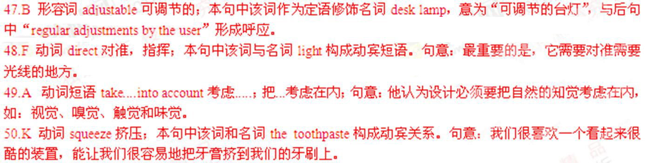
考点：考查选词填空www.gaosan.com
III.Reading Comprehension
Section A
Directions: For each blank in the following passage there are four words or phrases marked A, B, C and D.Fill in each blank with the word or phrase that best fits the context.
In the 1960s, Douglas McGregor, one of the key thinkers in the art of management, developed the mow famous Theory X and Theory Y.Theory X is the idea that people instinctively 51 work and will do anything to avoid it.Theory Y is the view that everyone has the potential to find satisfaction in work.In any case, despite so much evidence to the 52 , many managers still agree to Theory X.They believe, 53 , that their employees need constant supervision if they are to work effectively, or that decisions must be imposed from 54 without consultation.This, of course, makes for authoritarian (专制的) managers.Different cultures have different ways of 55 people.Unlike authoritarian management, some cultures, particularly in Asia, are well known for the consultative nature of decision-making—all members of the department or work group are asked to 56 to this process.This is management by the collective opinion.Many western companies have tried to imitate such Asian ways of doing things, which are based on general 57 .Some experts say that women will become more effective managers than men because they have the power to reach common goals in a way that traditional 58 managers cannot.
A recent trend has been to encourage employees to use their own initiative, to make decisions on their own without59 managers first.This empowerment (授权) has been part of the trend towards downsizing: 60 the number of management layers in companies.After de-layering in this way, a company may be 61 with just a top level of senior managers, front-line managers and employees with direct contact with the public.Empowerment takes the idea of delegation (委托) much further than has 62 been the case.Empowerment and delegation mean new forms of management control to 63 that the overall business plan is being followed, and that operations become more profitable under the new organization, rather than less.
Another trend is off-site or 64 management, where teams of people linked by e-mail and the Internet work on projects from their own houses.Project managers evaluate the 65 of the team members in terms of what they produce for projects, rather than the amount of time they spend on them.
51.A.desireB.seekC.loseD.dislike
52.A.contraryB.expectationC.degreeD.extreme
53.A.vice versaB.for exampleC.howeverD.otherwise
54.A.outsideB.insideC.belowD.above
55.A.replacing B.assessingC.managingD.encouraging
56.A.referB.contributeC.objectD.apply
57.A.agreementB.practiceC.electionD.impression
58.A.bossyB.experiencedC.westernD.male
59.A.askingB.trainingC.warningD.firing
60.A.doublingB.maintainingC.reducingD.estimating
61.A.honoredB.leftC.crowdedD.compared
62.A.economically B.traditionallyC.inadequatelyD.occasionally
63.A.denyB.admitC.assumeD.ensure
64.A.virtualB.ineffectiveC.day-to-dayD.on-the-scene
65.A.opinionB.riskC.performanceD.attractiveness
【答案】51.D52.A53.B54.D55.C56.B57.A58.D59.A60.C61.B62.B63.D64.A65.C
【解析】
试题分析：本文是说明文，作者在第一段中提出道格拉斯·麦克雷戈所提出的人性假设理论中的X理论和Y理论，并介绍了现代社会中一种新型管理理论：授权管理及其作用.
51.D考查上下文串联.根据后半句“....will do anything to avoid it”可知很多人为了避免工作而愿意做任何事情，说明那些人大多数人生性都是懒惰的，都不愿意工作，他们尽可能地逃避工作.故D项正确.
52.A考查上下文串联.短语to the contrary相反的；to the degree在某种程度上；to the extreme走向极端；在文章第一段中提到了X理论，大多数人都缺乏进取心和责任心，不愿对人和事负责，没有什么雄心壮志，不喜欢负责任，宁可被领导.而Y理论认为大多数人愿意对工作、对他人负责，人们愿意实行自我管理和自我控制来完成应当完成的目标.这是两种完全相反的理论，尽管对于这两种完全相反的理论有很多的证据，很多管理人仍然同意X理论.故A正确.
53.B考查上下文串联.本句中for example表示举例说明；这些管理人仍然同意X理论，例如他们认为如果要员工效率高，就需要给与他们不断的监督.这属于X理论的举例说明.故B正确.
54.D考查上下文串联.根据后句“...makes for authoritarian managers....”可知这属于专制的管理方法，他们的决定是来自上而下的，没有任何商量的余地.故D项“above上面的”正确.
55.C考查上下文串联.根据前段可知本文讨论的管理学的理论，使用本句使用动词“manage管理”，不同的文化中有不同的管理人的方法.而且和下文中亚洲、西方的管理方法形成呼应.故C正确.
56.B考查动词短语辨析.短语refer to提到，谈到；contribute to做贡献；导致；object to反对；apply to适用于；亚洲人使用的是协商式的管理方法，所有人都被要求对管理的过程做出自己的贡献.故B正确.
57.A考查上下文串联.名词agreement同意；practice练习，做法；election选举；impression印象；亚洲人使用协商式的管理方法，这种方法是建立在共同的协议基础之上的，西方人也想学习这样的管理方法.故A正确.
58.D考查上下文串联.根据前半句“....women will become more effective managers than men....”可知有些专家认为女性比男性管理更高效.因为女性更有亲和力，比男性管理人更容易与别人达成一致的目标.故D正确.
59.A考查上下文串联.根据前句“...encourage employees to use their own initiative...鼓励员工使用自己的首创精神”，也就是说在做出决定的时候不要请示上级经理，自己做出决定即可.故A项正确.
60.C考查上下文串联.根据前句“the trend towards downsizing缩小规模的趋势”，也就是要减少管理层的数量，可以直接做出决定而不需要请示上级.故动词“reduce减少”符合上下文串联.
61.B考查短语辨析辨析.动词be honored with被授予；be left with留下，剩下；be crowded with挤满；be compared with与..相比；通过这种方法，公司只剩下高层管理者和前线的与公众直接联系的一线管理人.省略了很多中央环节，提高了管理的效益.故B正确.
62.B考查副词辨析.副词economically经济地；traditionally传统地；inadequately不充分地；occasionally偶尔地；根据后句“Empowerment and delegation mean new forms of management...”可知授权管理是一个新型的管理方法，与传统的管理模式不一样.故B正确.
63.D考查动词辨析.动词deny否认；admit承认；assume假定，设想；ensure保证，确保；授权管理是一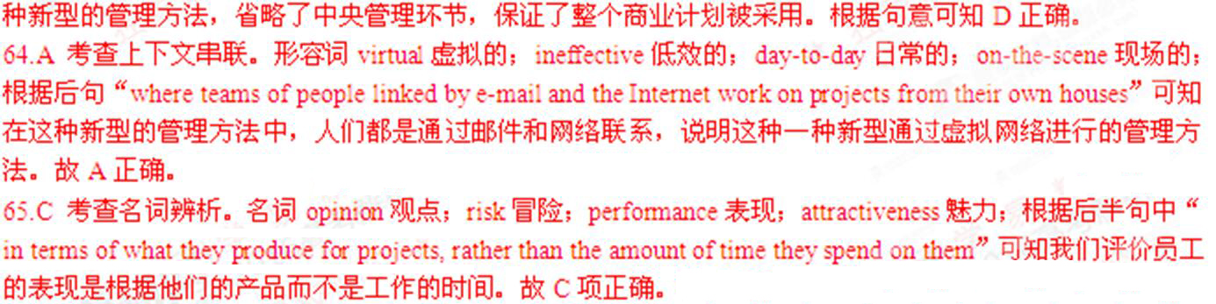
考点：考查说明文阅读
Section B
Direction：Read the following three passages.Each passage is followed by several questions or unfinished sattments.For each of them there are four choices markedA, B, C and D.Choose the one that fits best according to the information given in the passage you have just read.
(A)
One early morning, I went into the living room to find my mother reading a thick book called Best Loved Poems to Read Again and Again.My interest was aroused only by the fact that the word “Poems” appeared in big, hot pink letters.
“Is it good?” I asked her.
“Yeah,” she answered.“There’s one I really like and you’ll like it, too.” I leaned forward.“‘Patty Poem,’” she read the title.Who is Patty? I wondered.The poem began:She never puts her toys away,Just leaves them scattered① where they lay,…①散乱的The poem was just three short sections.The final one came quickly:When she grows and gathers poise②, ②稳重I’ll miss her harum-scarum③ noise, ③莽撞的And look in vain④ for scattered toys④徒劳地And I’ll be sad.
A terrible sorrow washed over me.Whoever Patty was, she was a mean girl.Then, the shock.
“It’s you, honey,” My mother said sadly.
To my mother, the poem revealed a parent’s affection when her child grows up and leaves.To me, the “she” in the poem was horror.It was my mama who would be sad.It was so terrible I burst out crying.
“What’s wrong?” my mother asked.
“Oh Mama,” I cried.“I don’t want to grow up ever!”
She smiled.“Honey, it’s okay.You’re not growing up anytime soon.And when you do, I’ll still love you, okay?”
“Okay,” I was still weeping.My panic has gone.But I could not help thinking about that silly poem.After what seemed like a safe amount of time, I read the poem again and was confused.It all fit so well together, like a puzzle.The language was simple, so simple I could plainly understand its meaning, yet it was still beautiful.I was now fascinated by the idea of poetry, words that had the power to make or break a person’s world.
I have since fallen in love with other poems, but “Patty Poem” remains my poem.After all, “Patty Poem” gave me my love for poetry not because it was the poem that lifted my spirits, but because it was the one that hurt me the most.
66.Why was the writer attracted by the book Best Loved Poems to Read Again and Again?
A.It was a thick enough book.
B.Something on its cover caught her eye.
C.Her mother was reading it with interest.
D.It has a meaningful title.
67.After her mother read the poem to her, the writer felt ______ at first.
A.sad
B.excited
C.horrified
D.confused
68.The writer’s mother liked to read “Patty Poem” probably because______.
A.it reflected her own childhood
B.it was written in simple language
C.it was composed by a famous poet
D.it gave her a hint of what would happen
69.It can be concluded from the passage that“Patty Poem”leads the writer to _______.
A.discover the power of poetry
B.recognize her love for puzzles
C.find her eagerness to grow up
D.experience great homesickness
【答案】66.B67.A68.D69.A
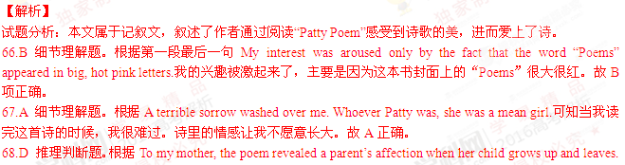
To me, the “she” in the poem was horror.It was my mama who would be sad.可知对妈妈来说这首诗让她想起我也会长大也会离开她，她也会因为我的离开而非常难受.所以这本书让她把未来可能发生的事情联系了起来.故D项正确
69.A 推理判断题.根据文章最后一段“I have since fallen in love with other poems, but “Patty Poem” remains my poem.After all, “Patty Poem” gave me my love for poetry not because it was the poem that lifted my spirits, but because it was the one that hurt me the most.”可知这首诗让作者感受了诗歌的美，让作者爱上了诗歌，这首因为她发现诗歌有强烈的情感冲击力.故A项正确.
考点：考查记叙文阅读
（B）
Is there link between humans and climate change or not? This question was first studied in the early 1900s.Since then, many scientists have thought that our actions do make a difference.In 1997, the Kyoto Protocol explained our role in the Earth’s changing atmosphere and set international limits for gas emissions(排放) from 2008 to 2012.Some countries have decided to continue these reductions until 2020.More recently, the Paris Agreement, stuck by nearly 200 countries, also aims to limit global warming.But just now how much warmer it will get depends on how deeply countries cut carbon emissions.3.5℃.This is how much temperatures would rise by 2100 even if nations live up to the initial Paris promises to reduce carbon emissions; this rise could still put coastal cities under water and drive over half of all species to extinction.2℃To meet this minimum goal, the Agreement requires countries to tighten emissions targets every five years.Even this increase could sink some islands, worse drought(干旱) and drive a decline of up to a third in the number of species.1.5℃This is the most ambitious goal for temperature rise set by the Paris Agreement, after a push by low-lying island nations like Kiribati, which say limiting temperature rise to 1.5℃ could save them from sinking.0.8℃
This is how much temperatures have risen since the industrial age began, putting us 40% of the way to the 2℃ point.0℃The baseline here is average global temperature before the start of the industrial age.
70.It can be concluded from paragraph 1 that ______.
A.the problem of global warming will have been quite solved by 2020
B.gas emissions have been effectively reduced in developed countries
C.the Paris Agreements is more influential than the Kyoto Protocol
D.humans have made continuous efforts to slow down global warming
71.If nations could only keep the initial promises of the Paris Agreement, what would happen by the year 2100?
A.The human population would increase by one third.
B.Little over 50% of all species would still exist.
C.Nations would not need to tighten their emissions targets.
D.The Agreement’s minimum goal would not be reached.
72.If those island nations not far above sea level are to survive, the maximum temperature rise, since the start of the industrial age, should be_______.
A.0.8℃B.1.5℃C.2℃D.3.5℃
【答案】70.D 71.D72.B
【解析】
试题分析：本文介绍了人们一直努力减少温室气体的排放，并设立了到2100年我们应该达成的目标以及达成目标要符合的条件.
70.D推理判断题.根据文章第一段三至六句“Since then, many scientists have thought that our actions do make a difference.In 1997, the Kyoto ......stuck by nearly 200 countries, also aims to limit global warming.”可知自从20世纪早期开始人类就一直在努力减少温室气体的排放，希望能减缓全球变暖的趋势.故D项正确.
71.D推理判断题.根据文章第二段This is how much temperatures would rise by 2100 even if nations live up to the initial Paris promises to reduce carbon emissions;可知如果各国的气体排放能够符合巴黎协议的要求，到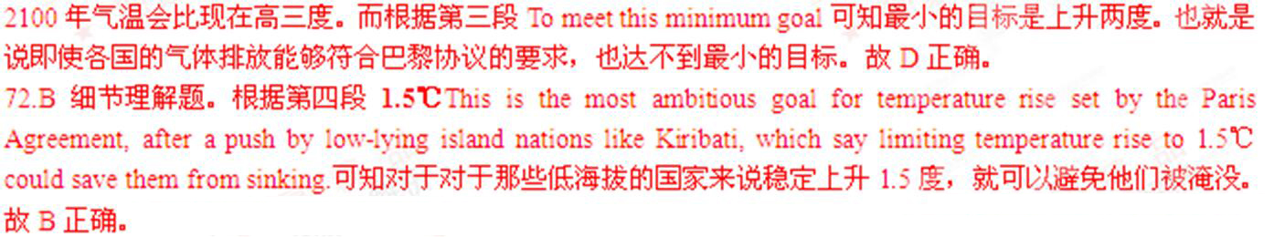
考点：考查说明文阅读
(C)
Enough “meaningless drivel”.That’s the message from a group of members of the UK government who have been examining how social media firms like LinkedIn gather and use social media data.
The House of Commons Science and Technology Committee’s report, released last week, has blamed firms for making people sign up to long incomprehensible legal contracts and calls for an international standard or kitemark (认证标记) to identify sites that have clear terms and conditions.
“The term and conditions statement that we all carelessly agree to is meaningless drivel to anyone,” says Andrew Miller, the chair of the committee.Instead, he says, firms should provide a plain-English version of their terms.The simplified version would be checked by a third party and awarded a kitemark if it is an accurate reflection of the original.
It is not yet clear who would administer the scheme, but the UK government is looking at introducing it on a voluntary basis.“we need to think through how we make that work in practice,” says Miller.
Would we pay any more attention to a kitemark? “I think if you went and did the survey, people would like to think they would,” says Nigel Shadbolt at the University of Southampton, UK, who studies open data.“We do know people worry a lot about the inappropriate use of their information.” But what would happen in practice is another matter, he says.
Other organisations such as banks ask customers to sign long contracts they may not read or understand, but Miller believes social media requires special attention because it is so new.“We still don’t know how significant the long-term impact is going to be of unwise things that kids put on social media that come back and bite them in 20 years’ time,” he says.
Shadbolt, who gave evidence to the committee, says the problem is that we don’t know how companies will use our data because their business models and uses of data are still evolving.Large collections of personal information have become valuable only recently, he says.
The shock and anger when a social media firm does something with data that people don’t expect, even if users have apparently permission, show that the current situation isn’t working.If properly administered, a kitemark on terms and conditions could help people know what exactly they are signing up to.Although they would still have to actually read them.
73.What does the phrase “ meaningless drivel” in paragraphs 1 and 3 refer to?
A.Legal contracts that social media firms make people sign up to.
B.Warnings from the UK government against unsafe websites.
C.Guidelines on how to use social media websites properly.
D.Insignificant data collected by social media firms.
74.It can be inferred from the passage that Nigel Shadbolt doubts whether _______.
A.social media firms would conduct a survey on the kitemark scheme
B.people would pay as much attention to a kitemark as they think
C.a kitemark scheme would be workable on a nationwide scale
D.the kitemark would help companies develop their business models
75.Andrew Miller thinks social media needs more attention than banks mainly because _______.
A.their users consist largely of kids under 20 years old
B.the language in their contracts is usually harder to understand
C.the information they collected could become more valuable in future
D.it remains unknown how users’ data will be taken advantage of
76.The writer advises users of social media to _______.
A.think carefully before posting anything onto such websites
B.read the terms and conditions even if there is a kitemark
C.take no further action if they can find a kitemark
D.avoid providing too much personal information
77.Which of the following is the best title of the passage?
A.Say no to social media?
B.New security rules in operation?
C.Accept without reading?
D.Administration matters!
【答案】73.A74.B75.D76.B77.C
【解析】
试题分析：当我们在社交媒体上注册登记的时候，总会签署一些无意义的法律合同，文章就此现象展开了讨论，并列举了多人的不同观点.
73.A词义猜测题.根据第一段第一句“......has blamed firms for making people sign up to long incomprehensible legal contracts....”可知很多社交媒体公司和用户签订了没有意义的法律合同.而这些合同是没有意义的废话，也起不到任何作用，很多用户根本没有仔细阅读合同的具体内容.故A正确.
74.B推理判断题.根据第五段前二句“Would we pay any more attention to a kitemark? “I think if you went and did the survey, people would like to think they would,” says Nigel Shadbolt at the University of Southampton, UK, who studies open data.”可知Nigel Shadbolt认为如果我们去做相关调查，人们会认为他们会很注意这些认证标记的.故B项正确.
75.D推理判断题.根据第六段最后一句“We still don’t know how significant the long-term impact is going to be of unwise things that kids put on social media that come back and bite them in 20 years’ time,” he says.可知我们现在还不知道所签署的这些长期的无意义的合同未来会给他们带来什么样的影响.也不知道未来人们会怎么利用这样的信息.故D项正确.
76.B推理判断题.根据文章最后一句If properly administered, a kitemark on terms and conditions could help people know what exactly they are signing up to.Although they would still have to actually read them.可知文章建议我们即使有认证标志，我们呀应该认真阅读那些无意义的合同中的条款和内容，我们要知道我们所签署的协议的具体内容.故B正确.
77.C标题概括题.现在的网站中或者社交媒体软件中，我们在注册用户名或安装的时候，总会有一些合同或条约让我们签署.很多人从来都没有详细阅读这些合同条款就签名了.文章就此话题展开讨论，作者提出我们应该仔细阅读条款内容，然后在签名.故C项“Accept without reading?未阅读就接受”符合文章中心思想.其余三项与文章内容不贴切.
考点：考查社会现象类阅读
Section C
Directions: Read the passage carefully.Then answer the questions or complete the statements in the fewest possible words.
Walking will be banned on escalators as part of a trail designed to reduce congestion(拥堵) at some of the country’s busiest stations.
In the first move of its kind, all travelers will be forced to stand on both sides of escalators on the London Underground as part of a plan to increase capacity(容量) at the height of the rush hour.
A six-month trial will be introduced at Holborn station from mid-April, eliminating the rule of standing on the right and walking on the left.The move, imitating a similar structure in Far eastern cities such as Hong Kong, is designed to increase the number of people using long escalators at the busiest times .it could be expanded across the Tube network in coming years.
According to London Underground, only 40 percent of travelers walk the full length of long escalators, leaving the majority at the bottom as they wait to get on to the “standing “side.
A three-week trial at Holborn last year found that the number of people using escalators at any time of could be raised by almost a third.Peter McNaught, operations director at London Underground, said: “It may not seem right that you can go quicker by standing still, but our experiments at Holborn have proved that it can be true.This new six-month trial will help us find out if we can influence customers to stand on both sides in the long term.”
Holborn has one of the longest sets of escalators on the Underground network at 23.4 high.Tube bosses claim that capacity was limited because so few people wanted to walk up—meaning only one side was used at all times.Research has shown that it is more effective use of escalators over 18.5 to ban walking.
The previous trial found that escalators at the station normally carried 2,500 people between 8:30am and 9:30am on a typical day, rising to 3,250 during the researching period.
In the new trial, which will be launched from April 18, one of three “up” escalators will be standing only, with a second banning walking at peak times.A third will remain a mix of walking and standing.
(Note: Answering the questions the questions or complete the statements in NO MORE THAN TEN WORDS.)
78.What is the existing problem with standing on the right and walking on the left?
79.What did last year’s three-week trial at Holborn station prove?
80.The research suggests that walking should be forbidden on escalators that are at least _________ in height.
81.In the new trail, in addition to one escalator banning walking in rush hours, the other “up” escalators will be used for_________________.
【答案】
78. The capacity of escalators hasn't been made full use of.
79. Passengers can go quicker by standing still.
80. 18.5m
81. standing only and a mix of walking and standing
【解析】
试题分析：本文属于议论文，禁止人们在电子扶梯上走动，并让所有的乘客站在扶梯的两边，这种做法增加了电子扶梯的容量，文章就此内容展开讨论.
78. The capacity of escalators hasn't been made full use of.
推理判断题.根据第二段In the first move of its kind, all travelers will be forced to stand on both sides of escalators on the London Underground as part of a plan to increase capacity(容量) at the height of the rush hour.所有的游客将被迫站在电子扶梯的两边，以增加电子扶梯的载客量，减轻高峰期的交通压力.也就是说原来的方法并没有充分利用好电子扶梯的容量.
79. Passengers can go quicker by standing still.
细节理解题.根据第五段第一句A three-week trial at Holborn last year found that the number of people using escalators at any time of could be raised by almost a third.可知在Holborn进行的为期的三周的测试发现乘客们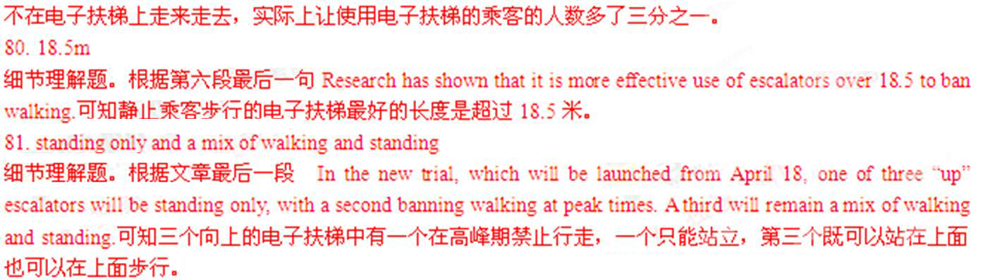
考点：考查任务型阅读
第II卷(共47分)
Translation
Directions: Translate the following sentences into English, using the words given in the brackets.
1.我真希望自己的文章有朝一日能见报.（hope）
2.二十世纪末中国经济迅速发展.（witness）
3.为买一双运动鞋而通宵排队有意义吗？（point）
4.虽然当时我年幼，不理解这部电影的含义，但我记得我的家人都感动得落泪了.（too…to…）
5.我阿姨苦读四年之后获得了文凭，那一刻她欣喜万分.（The moment…）
【答案】
1.I really hope that my article will be published in a newspaper someday.
2.The late twentieth century witnessed the rapid development of China’s economy.
3.What is the point of/in lining up for the whole night just to buy a pair of sports shoes? / Is there any point (in) lining up for the whole night just to buy a pair of sports shoes?
4.Although I was then too young to understand the meaning of the film, I remember my family were moved to tears.
5.The moment my aunt gained her diploma after four years of hard work, she was filled with joy.
【解析】
试题分析：
1.I really hope that my article will be published in a newspaper someday.
动词hope“希望”本身就含有未来的语义，后面所接从句通常表示将来的事情.本句中副词someday意为“有朝一日”通常和一般将来时连用.
2.The late twentieth century witnessed the rapid development of China’s economy.
动词witness目睹，见证；本句属于拟人化的修辞，使用无生命的事物做主语.同时注意时态，二十世纪属于过去的时间，所以使用一般过去时的时态.
3.What is the point of/in lining up for the whole night just to buy a pair of sports shoes? / Is there any point (in) lining up for the whole night just to buy a pair of sports shoes?
本句可以使用固定句型：There is a point in doing sth做某事有意义；
4.Although I was then too young to understand the meaning of the film, I remember my family were moved to tears.
本句中although引导让步状语从句，表示上下文的转折关系.同时固定结构“too...to...太....而不能.....”表示否定含义.
5.The moment my aunt gained her diploma after four years of hard work, she was filled with joy.
本句中名词短语the moment转换成连词短语，意为“一...就....”，引导时间状语从句.
考点：考查完成句子
II.Guided Writing
Directions: Write an English composition in 120–150 words according to the instructions given below in Chinese.
假设你是中华中学学生姚平，最近参加了一项研究性学习调研，课题为“父母是否以子女为荣”.通过调研你校学生及其父母，结果发现双方对此问题的看法有差异（数据如图所示）.根据图表写一份报告，在报告中，你必须：描述调研数据；分析可能导致这一结果的原因.
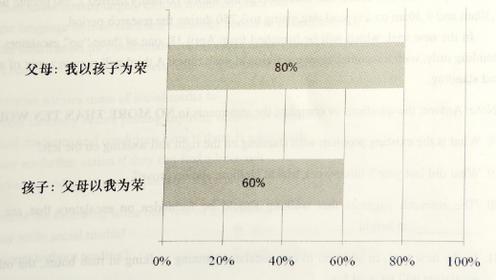
【答案】
（略）
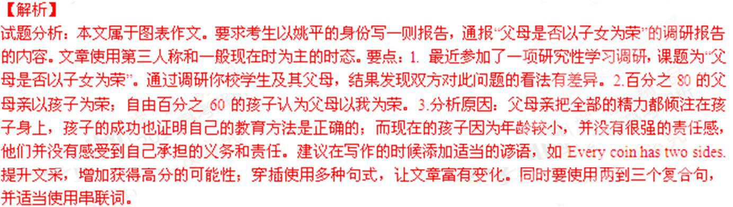
考点：考查图表作文

